# Explore Nairobi

## Location

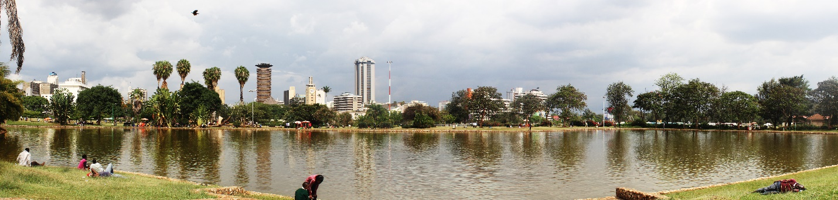

Nairobi is situated at 1°17′S 36°49′E in South-Central Kenya, 140 kilometers (87 miles) south of the equator. It is surrounded by 113 km² (70 mi²) of plains, cliffs and forest that makes up the city’s Nairobi National Park. It is adjacent to the eastern edge of the Rift Valley, and to the west of the city, are The Ngong Hills. Mount Kenya is situated north of Nairobi, and Mount Kilimanjaro is towards the south-east.

It is the most populous city in East Africa, with a current estimated population of about 3.5 million. This makes it the 14th largest city in Africa.

Being Kenya’s capital, and the arrival point for many visitors, it is well served by international airlines, and a regional road network linking it to other major East African urban centers. Railways link Nairobi to Mombasa, Kenya ' s second largest city located on the shores of the Indian Ocean and Kisumu, the third largest city, located on the shores of Lake Victoria.

## Highways

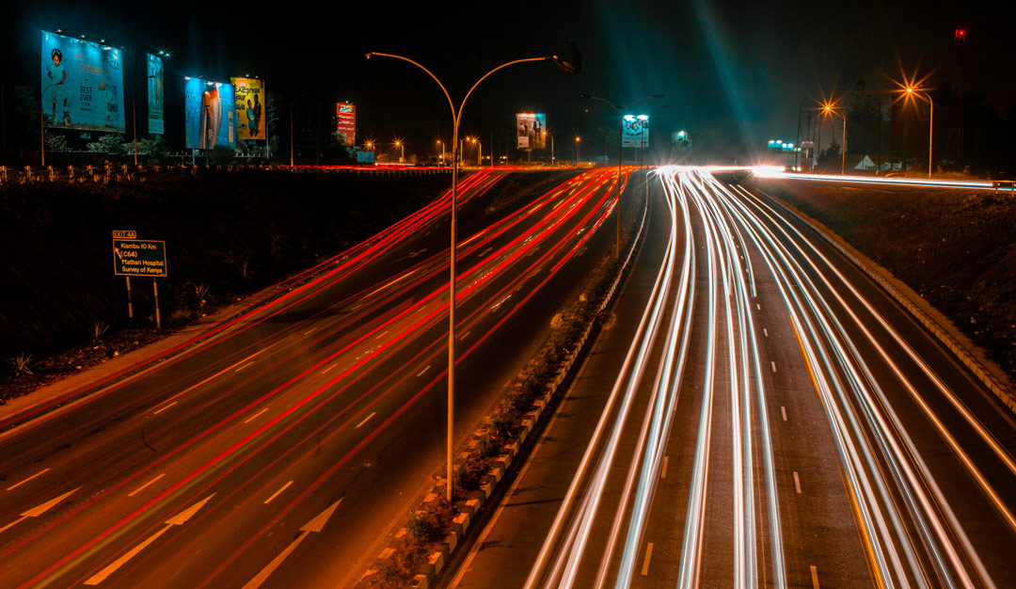

Nairobi is connected by tarmacked roads to Kenya’s other major urban centers, such as Mombasa, Kisumu, Nakuru, Nyeri, Eldoret, Garissa, Machakos, Kisii, and Kericho among others. The City is currently undergoing major road constructions to update its infrastructure network. Most roads are well lit and surfaced with adequate signage. Bypasses are currently under construction and seek to ease congestion in Nairobi's downtown area and the surrounding suburbs. The Bypasses comprise the:

1. Northern bypass – linking Limuru road to Thika Road
2. Eastern bypass – linking Mombasa road to Ruiru-Kiambu road near Kamiti prison
3. Southern bypass – run from Kikuyu to Mombasa road via Ngong road & Langata

## Bus and Matatu Service

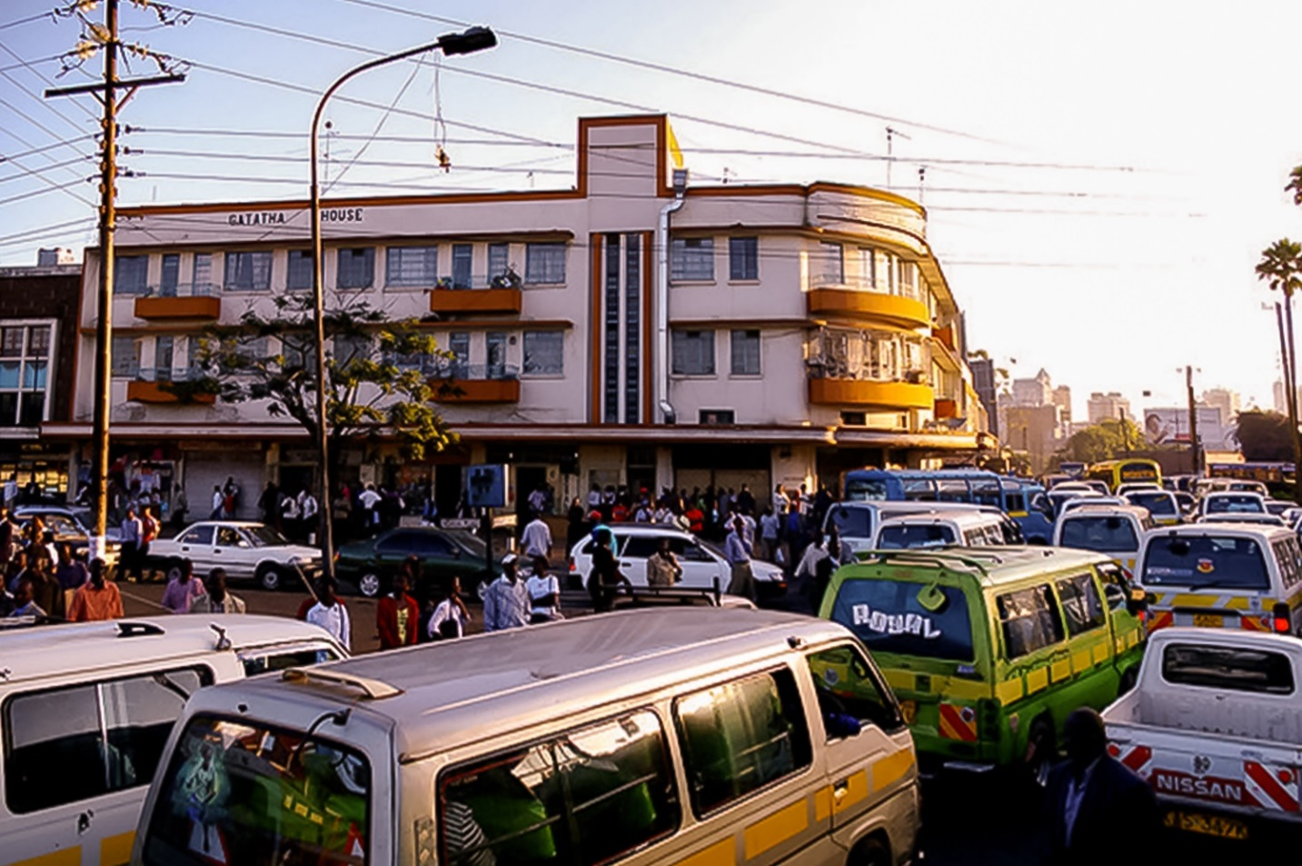

A matatu (public minibuses/commuter buses) is typically used for traveling between downtown Nairobi and the suburbs. They are the most common form of public transport and provide a cheap way of getting around Nairobi.

Matatus vary in size, between the van sized 14 seat Matatus and the larger 50-seat buses. The matatu's destination is imprinted along a yellow stripe on the side of the bus, and matatus plying specific routes have specific route numbers.

They are usually packed during the morning rush hours as people head to work and in the evening as they return home. However, at other times and on weekends, the congestion is not bad.

There are a large number of long-distance bus companies in Nairobi that provide transportation to most areas of the country. Long-distance buses also provide service to major cities in Uganda and Tanzania. In addition to long-distance buses, there are mini-buses with regular service to Mombasa and shared taxis to nearby urban centers including the Kenya-Tanzania border. Shared taxis are Peugeot station wagons that usually carry seven passengers.

Often the minibuses and shared taxis leave when they are full and therefore do not follow fixed schedules. While the large buses often follow a schedule though at times they operate along lines similar to those of shared taxis and leave only when full.

## Airport

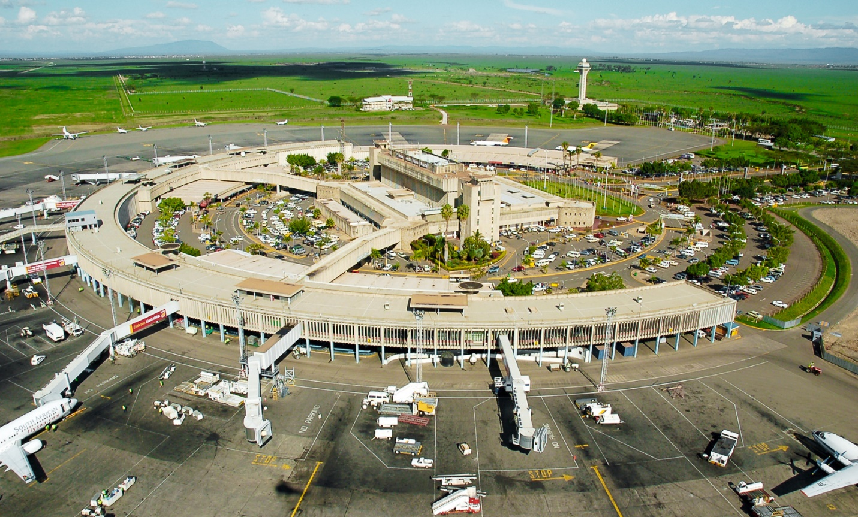

Nairobi is served primarily by Jomo Kenyatta International Airport. It is the largest airport in East and Central Africa. The airport is situated 17 km (10 miles) from Nairobi's Central Business District. The airport directly serves intercontinental passengers from Europe, the Middle East and Asia as well as internal flights to Eldoret, Kisumu on Lake Victoria and Malindi & Mombasa on the Coast. In addition to Kenyan Airlines, Jomo Kenyatta International Airport is serviced by a large number of international airlines.

Wilson Airport is a smaller and busy general aviation airport located in a south-central suburb of Nairobi West. It handles small aircraft that generally operate within Kenya, although some offer services to other East, Central and North-east African destinations.

## Taxi and Shared Taxi

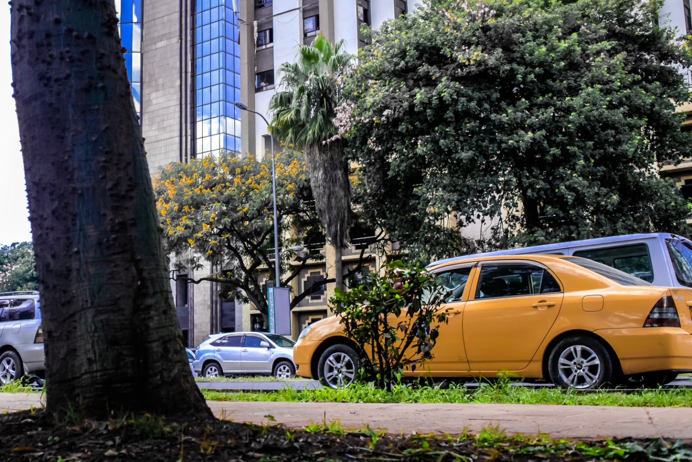

Taxis are a more expensive but more reliable mode of transportation than the matatus. They come in all shapes and conditions, including some London-style cabs. Usually, they are not metered and, like most other things in Nairobi, their fares are negotiable. Taxis are available in most parts of the city. They park outside hotels, at taxi ranks in the city centre, and at shopping malls.

Hotels and restaurants can order taxis if necessary. Nairobi Taxis are usually marked with a yellow line along each side.

There are several companies operating Dial Taxi services with phone bookings, modern vehicles, competent drivers and reasonable rates. Several Taxi companies have airport booking offices.

Shared taxis, operate on some routes and also take passengers to nearby towns.

## Motorcycles

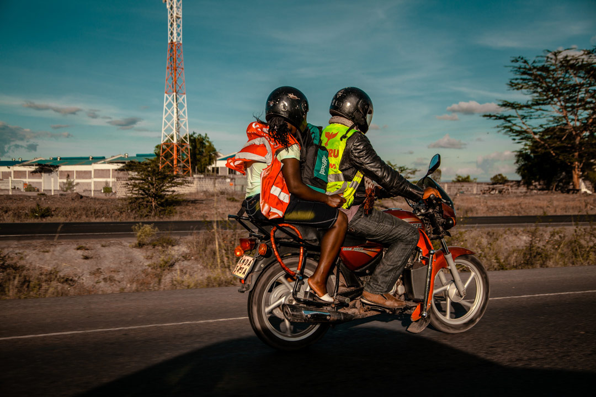

Popularly known as ‘Boda Boda’, Motorcycles are a convenient and affordable way to weave through Nairobi Traffic. Motorcycles provide a quick and safer means to navigate the city’s residential areas by night as they can easily navigate narrow foot-paths. This has helped open up transport to more remote parts of the city.

Regulations have been enacted that secure the riders safety through safety gear such as helmets and reflective jackets.

## Commuter Rail Service

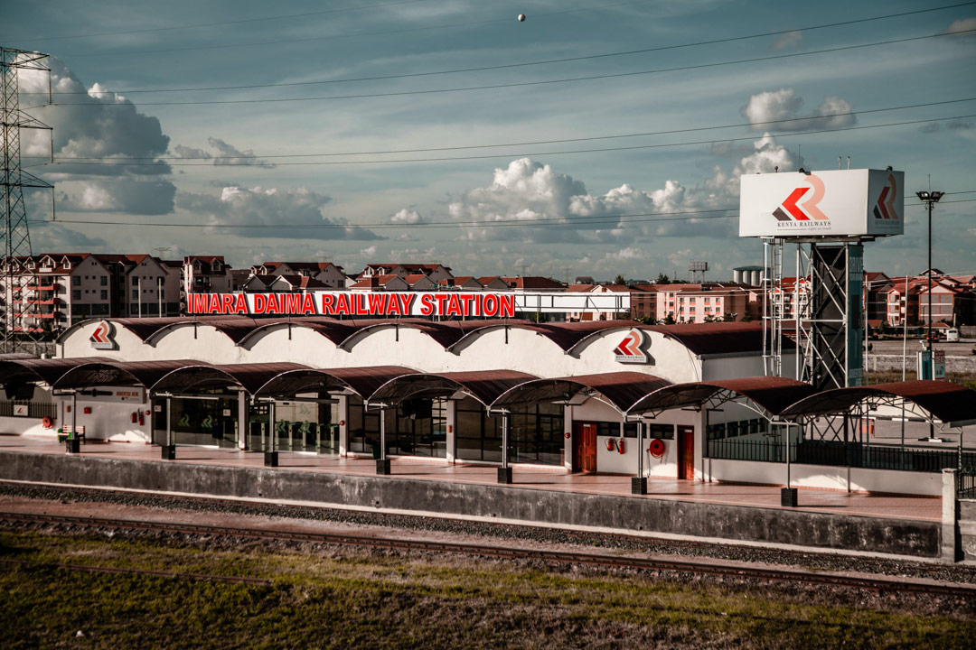

Nairobi was founded as a railway town, and the main headquarters of Kenya Railways is still situated at Nairobi Railway Station, which is located near the city centre. The line runs through Nairobi, from Mombasa to Kampala. Its main use is freight traffic, but regular nightly passenger trains connect Nairobi to Mombasa and Kisumu.

A number of morning and evening commuter trains connect the centre with the suburbs. These include the Syokimau Station and those along Jogoo Road, Imara Daima and Makadara Estates.

## Car Hire and Rental

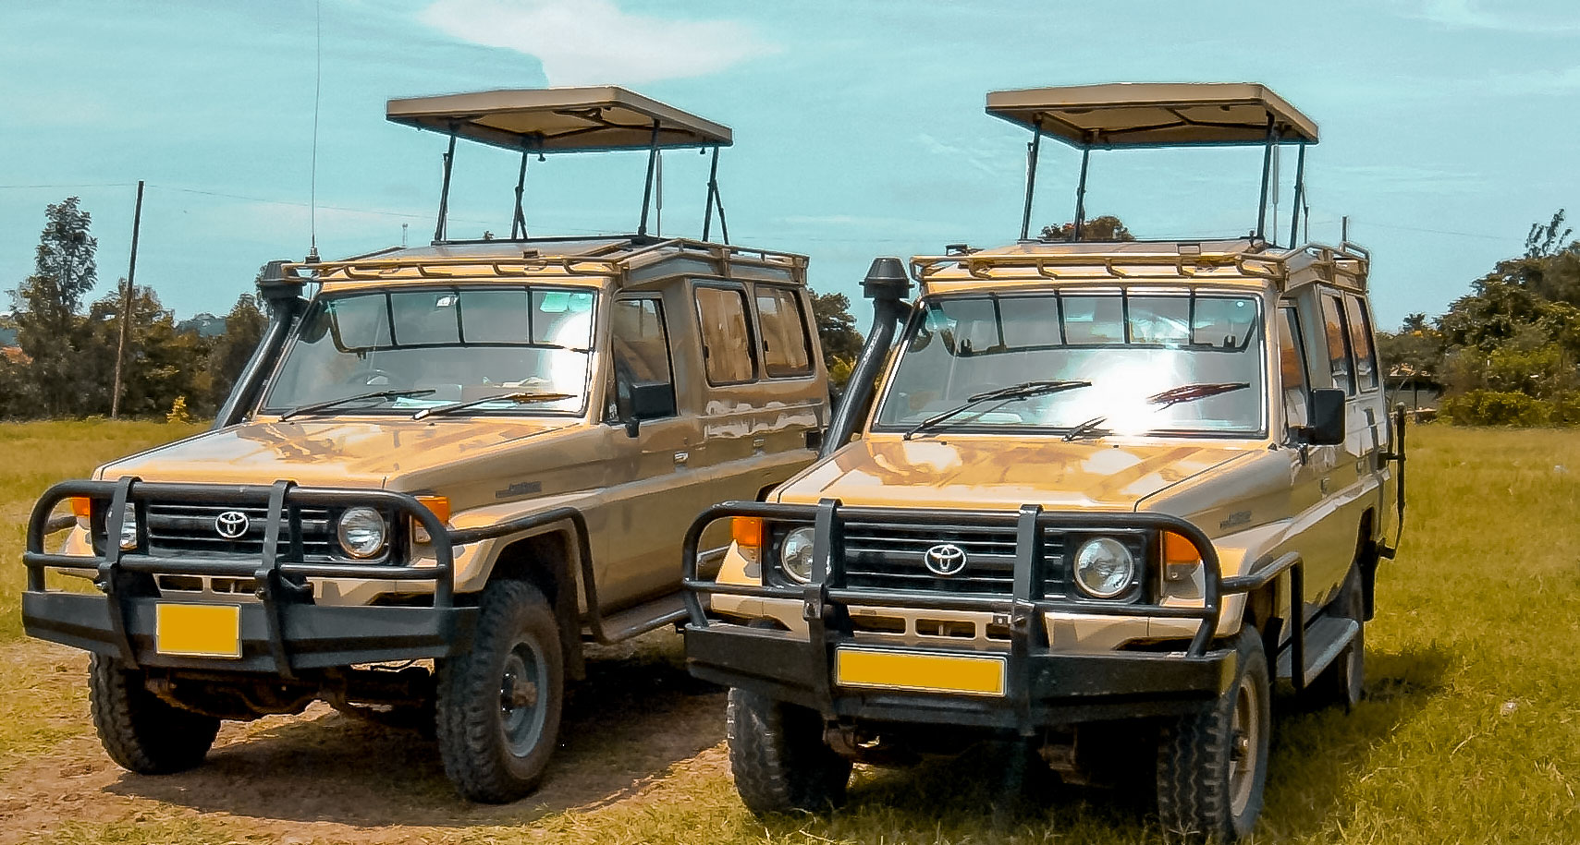

Vehicles are subject to customs duties of up to 70%, and this in turn pushes up car hire prices. Many of the usual International car hire chains have franchises in the city and several rental options are available. Cars can be hired with a driver (chauffeur-driven) or on self-drive basis. Carefully read the rental contract to check for rules on insurance liabilities in case of accident or theft of the vehicle.

Local car hire firms are available, often on a cash-in-advance basis. These operators are cheaper and more flexible than the international brands, but you risk greater levels of hassle in the event of an accident, theft or breakdown.

## Walking

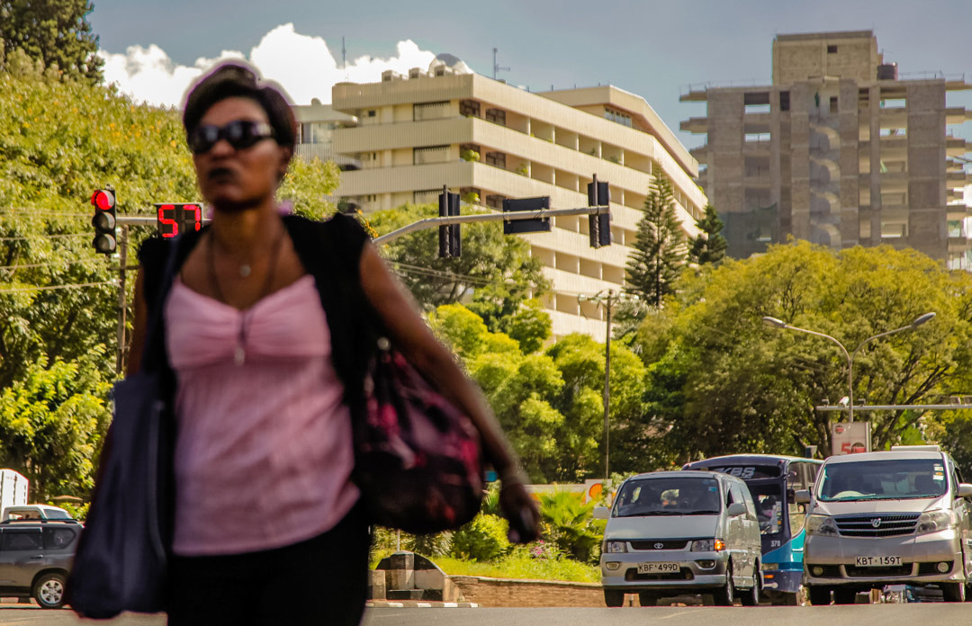

Because traffic congestion is a major problem in downtown Nairobi, walking is the best way to get around the city center. The distances are short, and the streets are well marked. However, some areas are unsafe, and it is best to seek local advice before setting out.

## Sightseeing

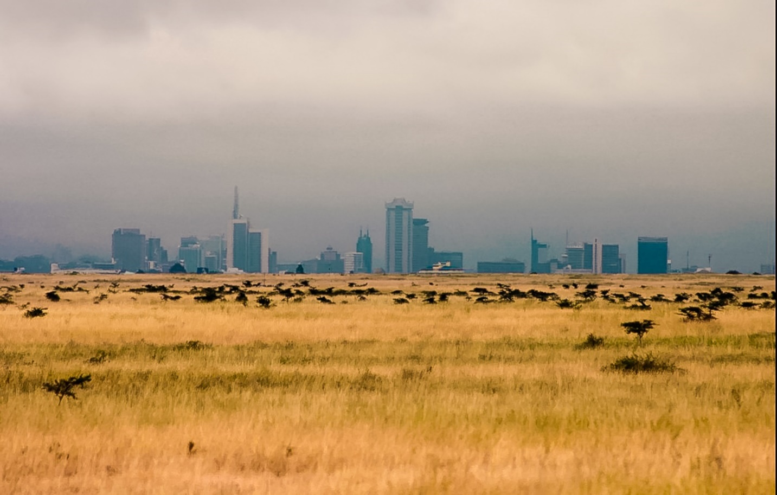

Nairobi is home to many tour operators and travel agents. Excursions can be arranged to all parts of the city and beyond.

Tours of Nairobi will normally include visits to

Nairobi National Park. This is home to large herds of Zebra, Wildebeest, Buffalo, Giraffe, Lion, Cheetah, Hippo, Rhino and even birdlife (over 400 species). Within it is Nairobi Animal Orphanage and the Nairobi Safari Walk, an Educational Centre that teaches wildlife and habitat conservation.

Sheldrick Elephant Orphanage, close to the Nairobi National Park. This Orphanage takes in elephant calves and rhinos from all over Kenya which were orphaned by poaching.

Giraffe Centre, in Lang'ata. The Centre breeds the endangered Rothschild Giraffe and has conservation/education programs for Kenyan children. It also has many warthogs. Here you can feed giraffes by hand and even get a kiss (their tongues can get up to 20" long and are antiseptic).

Mamba Village. This pleasant park is home to ostriches and crocodiles. You get the chance to interact directly with crocodiles and even hold a baby, with very knowledgeable employees serving as guides.

US Embassy Memorial Site, in the City Centre. In 1998 a blast rocked downtown Nairobi. A truck had exploded next to the US Embassy building, reducing it to rubble and killing 212 people some on staff, most bystanders. On the same day, August 7, the US embassy in Dar Es Salaam, Tanzania, was also subject to a similar terrorist attack. The former embassy site today contains a memorial that can be visited.

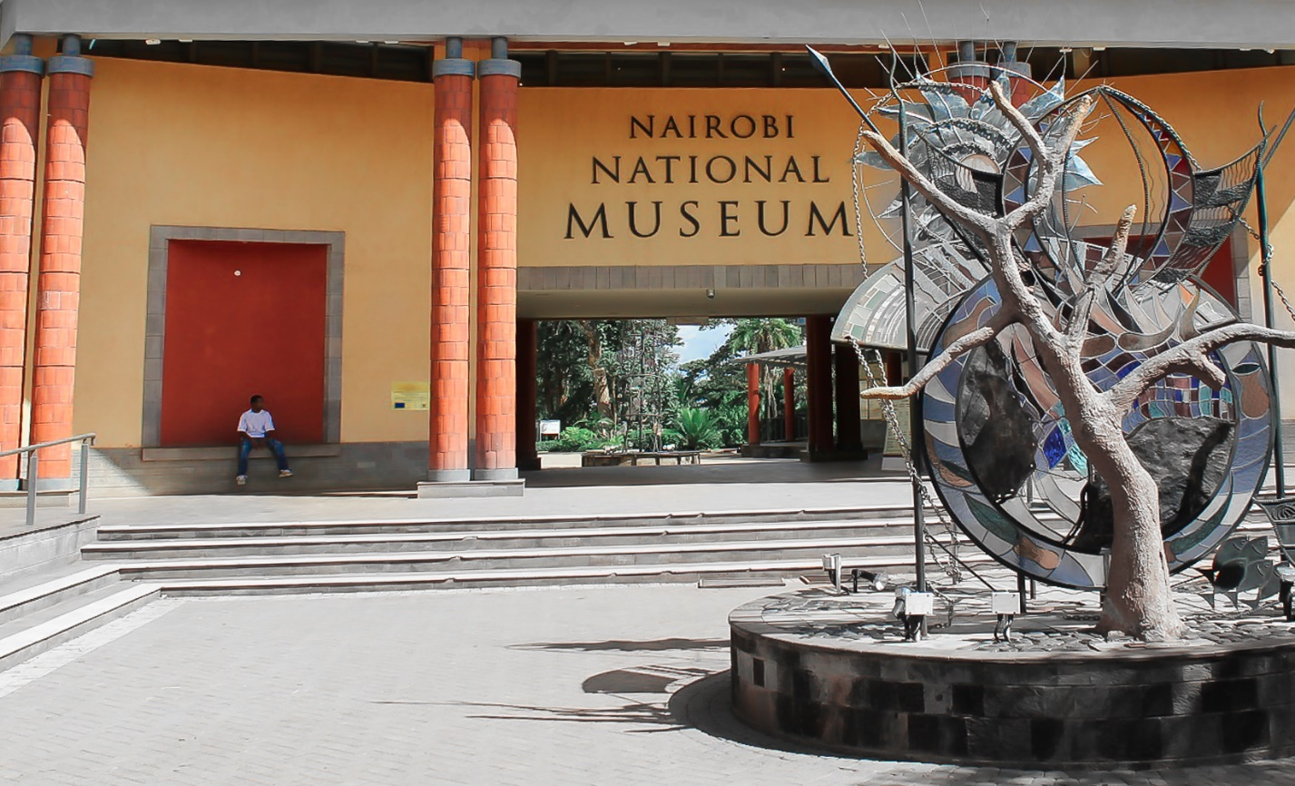

Nairobi National Museum. This is where visitors can learn about Kenya, its history and culture.

National Railway Museum, visitors can learn more about the history of Kenya’s railroads and the Kenya/Uganda railway. It also houses, some of the engines and rolling stock from the country’s colonial period.

Karen Blixen Museum, is based on the Karen Blixen’s book "Out of Africa". Her house is now the home of the museum. It is on the outskirts of Nairobi.

Bomas of Kenya, portrays Kenya’s culture. Visitors can see exhibits of traditional Kenyan homes, artifacts, dances, music, and song.

Uhuru Gardens, built in remembrance of the struggle for independence, which Kenya was granted in 1963. The monument is a 24-m (79 ft.) high triumphal column supporting a pair of clasped hands and the dove of peace, high over a statue of freedom fighter raising the flag. The monument is surround by fountains and lush-landscaped gardens.

## Parks and recreation

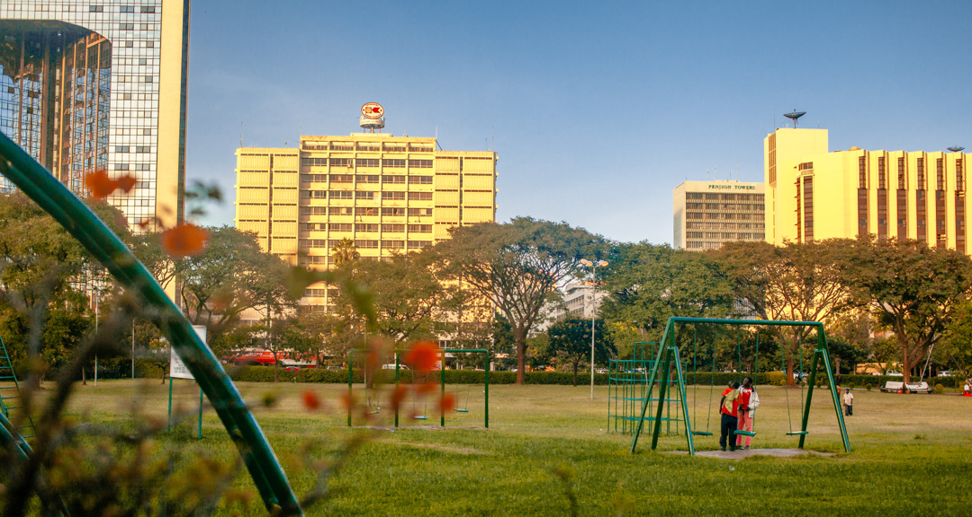

Nairobi offers some beautiful getaways from the hustle of city life.

The Uhuru Park (Nairobi’s Central Park) is a well maintained park that truly earns the city the tag as ‘the green city in the sun’. Nairobi residents, tourists, students and business people from all works of life visit the park every day for picnics, study, rest and a host of other activities. The serene park is a great place to take a breath or spend time with family and friends.

Other parks in the city include the Jeevanjee gardens, the City Park and the Karura Forest Sanctuary. These are just some of the must visit places when you are in Nairobi.

## Convenient Parking in the city

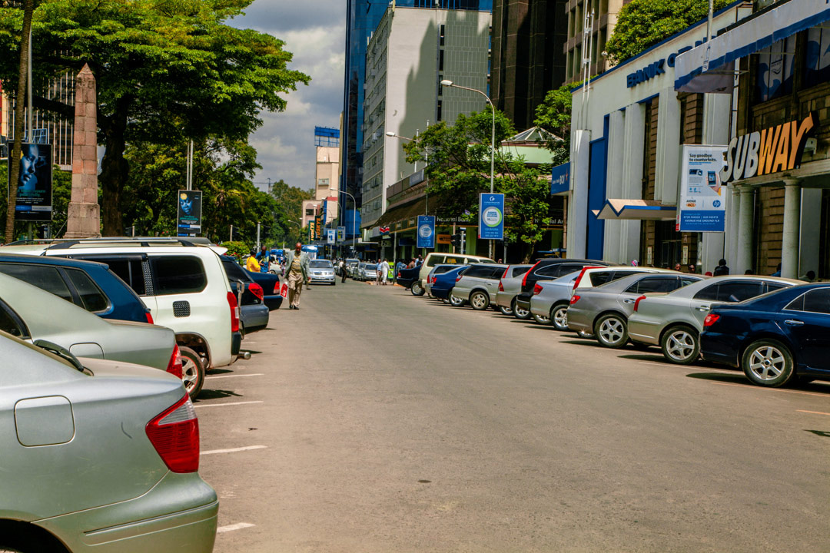

To streamline and make parking in the City more convenient and friendly to motorists, the Nairobi City County has installed and operationalized 20 booths all over the CENTRAL BUSINESS DISTRICT and WESTLANDS from where the motorists can access and buy parking tickets. Motorists can access and buy parking tickets. Motorists are further advised to make use of Seasonal Parking Tickets available at City Hall. Seasonal tickets are cheaper and time saving.

## Accommodation

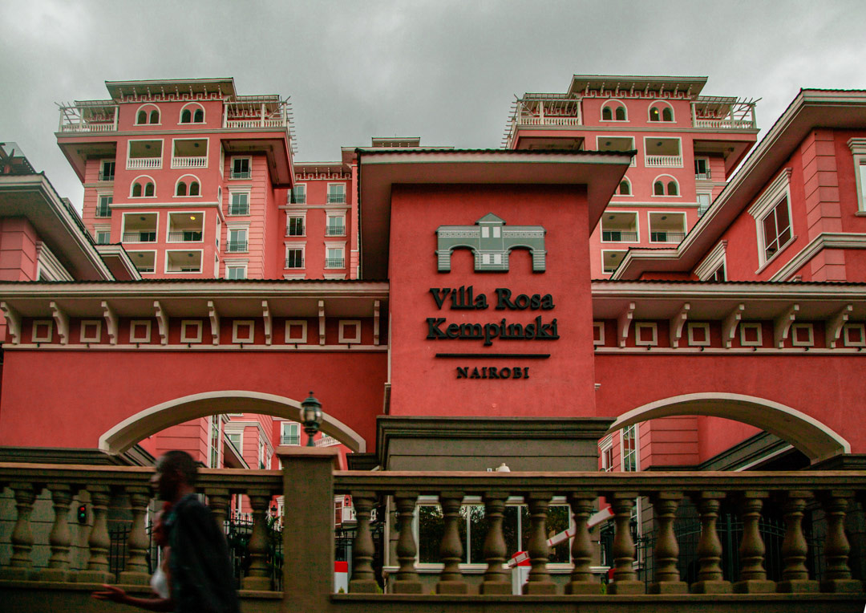

Nairobi is home to a variety of world class hotels including The Villa Rosa Kempinski Nairobi, The Hilton Hotel Nairobi, and the Stanley.

A number of new hotels and resorts have sprung up around the city over recent years to meet the high demand for accommodation both in the low end and high end market.

## Shopping

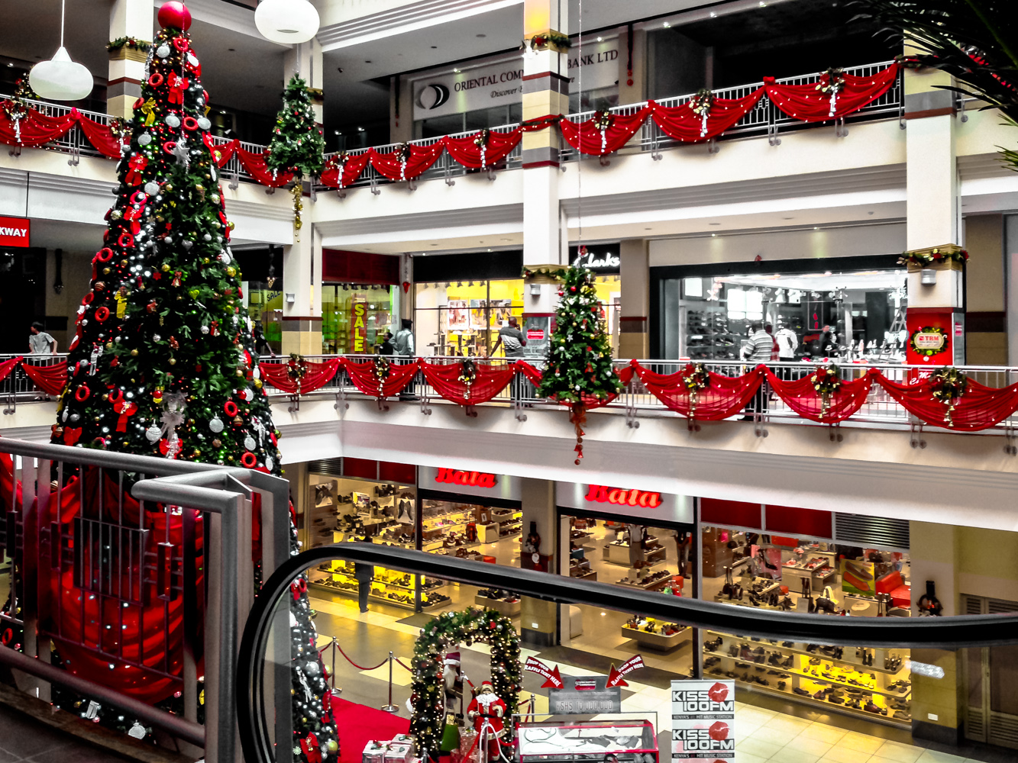

Downtown Nairobi, once the center for government, institutional and private office space is now a bustling shopping district where local and international brands compete for Kenya’s growing middle class. The streets are lined with shops, supermarkets, fast food restaurants and stalls where you can buy anything from high end electronics to low cost clothing. Nairobi’s shopping district is a diverse ecosystem that caters for every budget and every lifestyle.

Grand shopping malls are now a common site in residential neighborhoods in Nairobi providing access to many local and international brands, products and services.

## Thrift Shopping

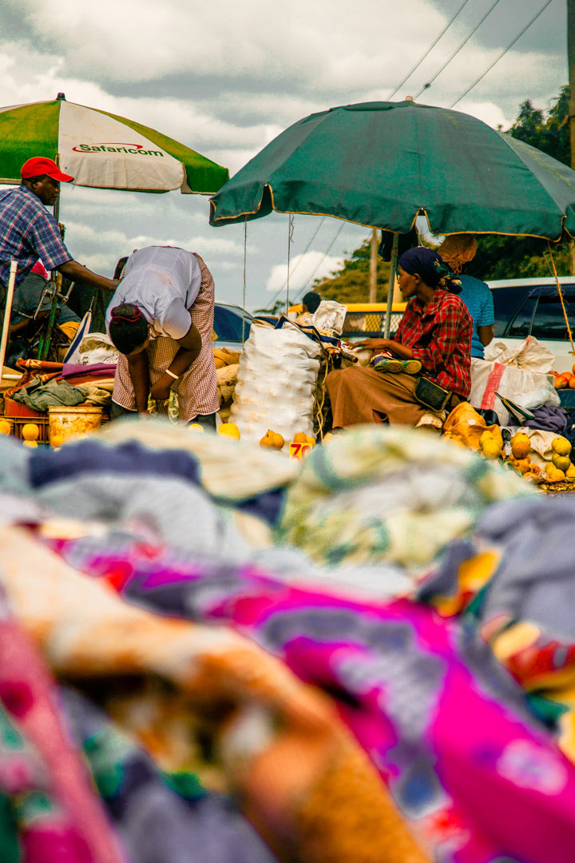

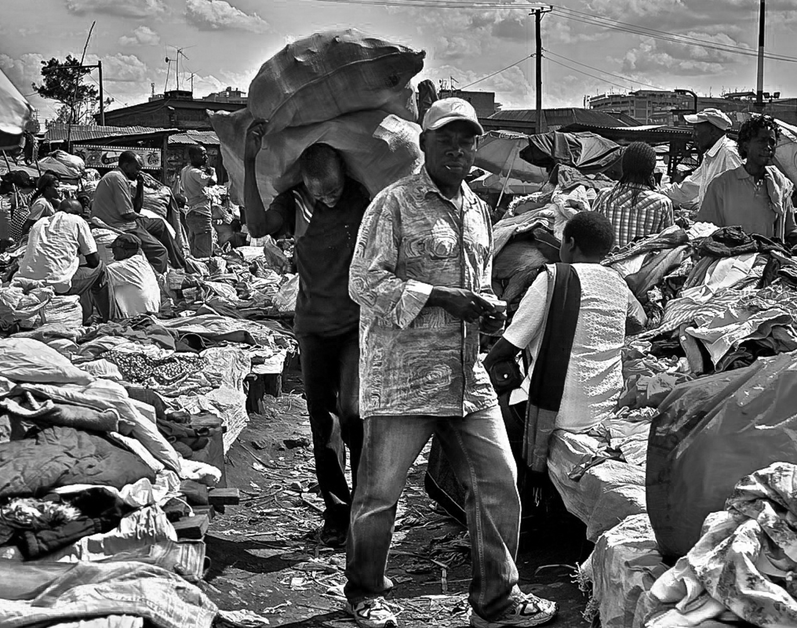

When on a budget, visit one of many thrift markets around the city. The Gikomba market is Kenya’s largest flea market situated a short matatu ride from the city center. It offers affordable clothing, furniture, accessories, books, hardware, fresh produce and processed materials.

Other markets include the Toi Market on Ngong Rd, the City Market in Downtown Nairobi, Muthurwa market on Jogoo Rd, and Githurai Market off The Thika Super-highway.